# Second Year B. Tech (EL&CE)

**Semester: IV Subject:** Basic IoT Laboratory

**Name: Shreerang Mhatre Class: SY**

**Roll No: 29 Batch: A2**

# Experiment No: 04

**Name of the Experiment**: Understanding Node MCU as development platform and connecting to Wi-Fi network through Arduino IDE.

**Performed on: 22/02/2023**

**Teacher’s Signature with date**

|  |
| --- |
| **Marks** |
|  |
|  |

**Submitted on: 04/03/2023**

**Aim:** Understanding Node MCU as development platform and connecting to Wi-Fi network through Arduino IDE.

**Prerequisite:** C or C++ Programming, NodeMCU board layout, NodeMCU pin configuration, Arduino IDE

# Objectives:

1. To understand integration of NodeMCU board with Arduino IDE
2. To Configure and upload code on ESP8266 module
3. To interface sensor with NodeMCU and check output with Arduino IDE.
4. To connect the NodeMCU ESP8266 to the Wi-Fi router using SSID and password of our Home network Wi-Fi

# Components and equipment required:

NodeMCU Board, USB cable, Arduino IDE, PIR Sensor (HC-SR501), LED, Buzzer, Bread board, Jumper wires etc.

# Theory:

PIR sensors allows to sense motion, generally used to detect whether a human has moved in or out of the sensors range. They are small, inexpensive, low-power, easy to use and don't wear out. They are commonly found in appliances and gadgets used in homes or businesses. They are often referred to as PIR, "Passive Infrared", "Pyroelectric", or "IR motion" sensors. When any body (human, animal or body emitting infrared radiations) emitting heat waves comes close to PIR sensor, PIR motion sensor will instantly detect the presence of it and rings a buzzer alarm to notify about an intrusion. Every body emits heat waves and heat waves contains infrared

rations. Generally the living bodies emit more heat than the raw materials. So PIR sensor can be used to detect the motion of living bodies.

PIR stands for passive infrared sensor. From passive it means it did not emit anything by its own to detect presence of a body, rather it receives the infrared waves emitted by the bodies and generates a presence alert as output. Infrared radiations cannot be seen by naked human eye. PIR motion detection sensors has a pyroelectric sensor in them. Pyroeletric sensor is enclosed in a round shaped lens or plastic material. The lens or plastic material focuses the received infrared radiations from body on a single point on pyroelectric sensor. Presence alert by PIR sensor depends on the strength of the infrared radiations received on the pyroelectric sensor. The sensitivity and range of PIR motion sensors can be varied.

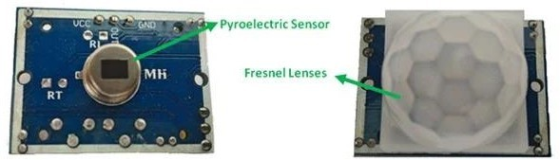

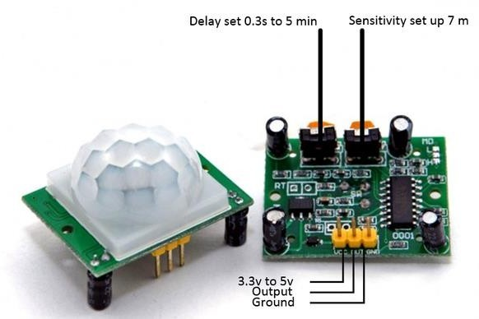

# Working Principle:

**Figure 4.1:** PIR Sensor Pin Out

Generally, PIR sensor can detect animal/human movement in a requirement range. PIR is made of a pyroelectric sensor, which is able to detect different levels of infrared radiation. The detector itself does not emit any energy but passively receives it.

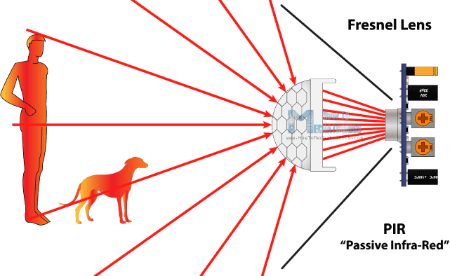

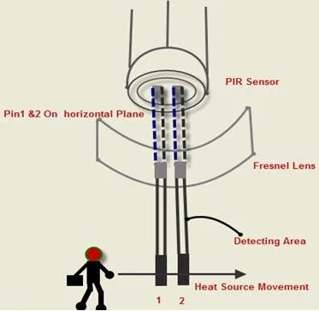

**Figure 4.2:** PIR Sensor Working Principle

It detects infrared radiation from the environment. Once there is infrared radiation from the human body particle with temperature, focusing on the optical system causes the pyroelectric device to generate a sudden electrical signal. Passive infrared alarms classified into infrared detectors (infrared probes) and alarm control sections. The most widely used infrared detector is a pyroelectric detector. It uses as a sensor for converting human infrared radiation into electricity. If the human infrared radiation is directly irradiated on the detector, it will, of course, cause a temperature change to output a signal. But in doing all this, the detection distance will not be more. In order to lengthen the detection distance of the detector, an optical system must be added to collect the infrared radiation. Usually, plastic optical reflection system or plastic Fresnel lens used as a focusing system for infrared radiation.

# Circuit Connections:

* Anode terminal of LED is connected to D4 pin of NodeMCU and cathode terminal is connected to GND of NodeMCU
* Long terminal (+ve) of buzzer is connected to D5 pin of NodeMCU and short terminal (-ve) of buzzer is connected to GND pin of NodeMCU.
* OUT pin of PIR sensor is connected to D8 pin of NodeMCU, GND pin of PIR sensor is connected to GND of NodeMCU and VCC pin of PIR sensor is connected to 3.3V pin of NodeMCU

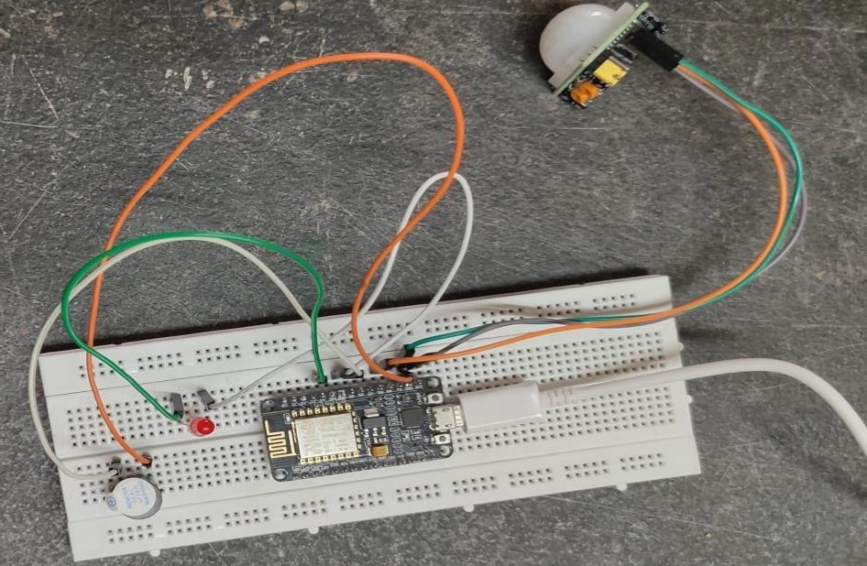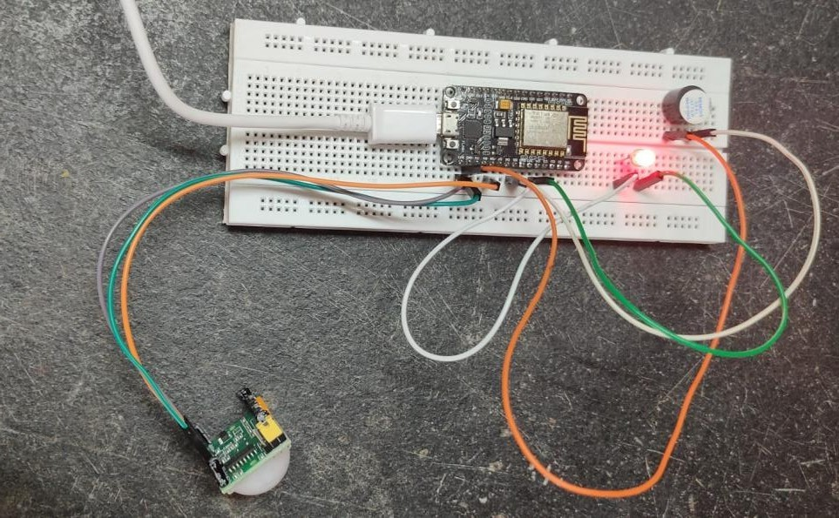

**Figure 4.3:** Circuit Connection

# Connecting NodeMCU to Wi-Fi network through Arduino IDE:

When it comes to connecting your Arduino to the internet there are many options, but one of the most popular and widely available is the ESP8266. NodeMCU is an open source platform based on ESP8266 which can connect objects and let data transfer using the Wi-Fi protocol. In addition, by providing some of the most important features of microcontrollers such as GPIO, PWM, ADC, and etc, it can solve many of the project’s needs alone. The ESP8266 is a microcontroller

developed by Espressif Systems. Known as a WiFi module, this microcontroller can be used to perform various WiFi-related activities, with applications in home automation and beyond.

Devices that connect to Wi-Fi networks are called stations (STA). Connection to Wi-Fi is provided by an access point (AP) that acts as a hub for one or more stations. The access point on the other end is connected to a wired network. An access point is usually integrated with a router to provide access from a Wi-Fi network to the internet. Each access point is recognized by a SSID (Service Set IDentifier) that essentially is the name of network you select when connecting a device (station) to the Wi-Fi.

ESP8266 modules can operate as a station, so we can connect it to the Wi-Fi network. It can also operate as a soft access point (soft-AP), to establish its own Wi-Fi network. When the ESP8266 module is operating as a soft access point, we can connect other stations to the ESP module. ESP8266 is also able to operate as both a station and a soft access point mode. This provides the possibility of building e.g. mesh networks.

# Circuit Connections:

* Anode terminal of LED is connected to D7 pin of NodeMCU and cathode terminal is connected to GND of NodeMCU
* Write sketch for accessing WiFi connectivity
* Once connected to WiFi, reflect LED ON/OFF status on Serial Monitor

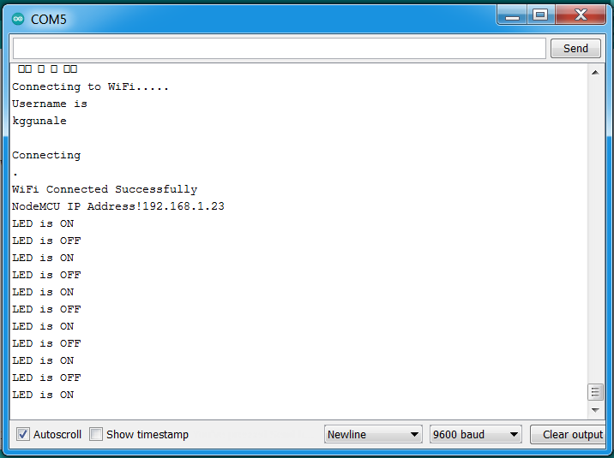

**Figure 4.4:** WiFi Connectivity status and LED Status on Serial Monitor

# Conclusion:

**Post Lab Questions:**

1. List Different motion sensors available and explain any one.
2. Compare between ESP32 and ESP8266
3. List out various applications of PIR sensor and explain any one in detail
4. Mention various pins of ESP8266 NodeMCU and explain in detail all the Pins.

# Additional links for more information:

1. IoT Automation with ESP8266

<https://www.udemy.com/course/iot-internet-of-things-automation-with-esp8266/>

1. Establishing a WiFi Connection

<https://tttapa.github.io/ESP8266/Chap07%20-%20Wi-Fi%20Connections.html>

1. IoT based Home automation using PIR sensor and Blynk App

<https://www.ijeat.org/wp-content/uploads/papers/v9i4/D7583049420.pdf>

1. Insight into ESP8266 NodeMCU Features <https://lastminuteengineers.com/esp8266-nodemcu-arduino-tutorial/>

**PIR sensor without WIFI**

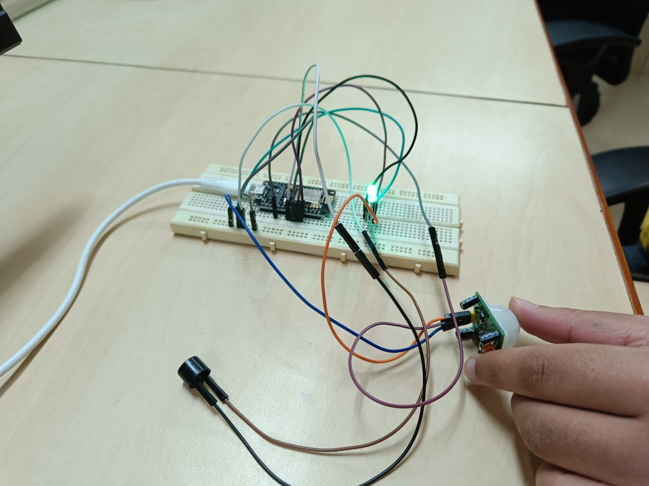



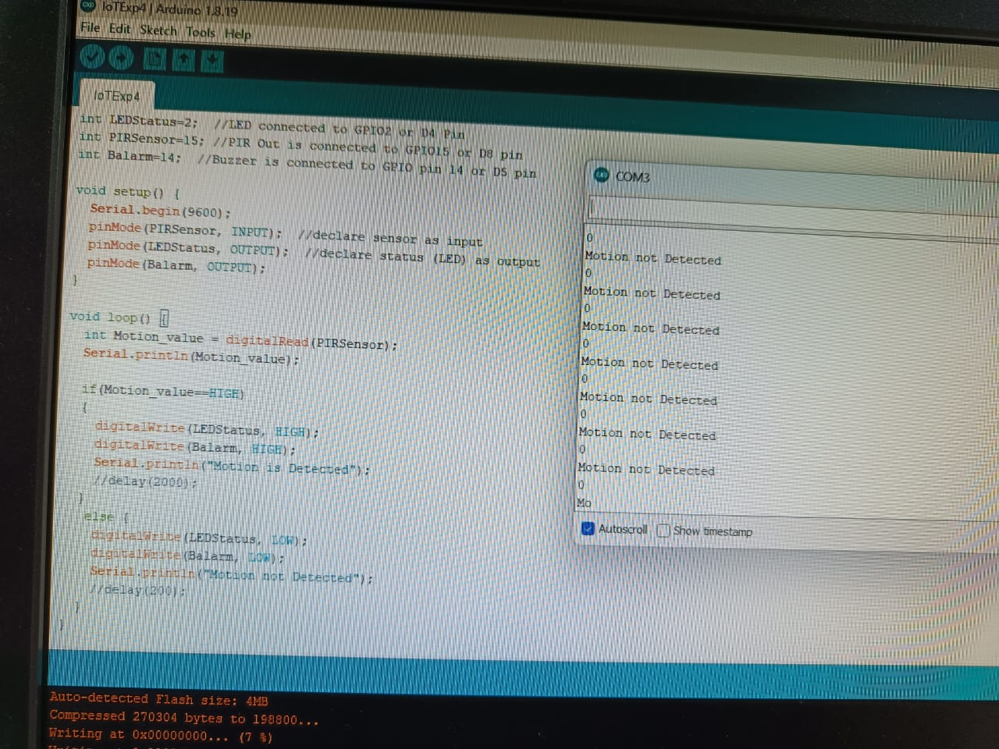

**With WIFI**

